COINS-Constatine I (306-337) AE3-320 CE- SOLI INVICTO COMITI

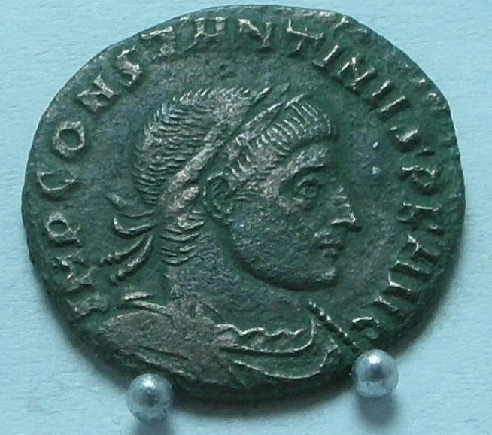 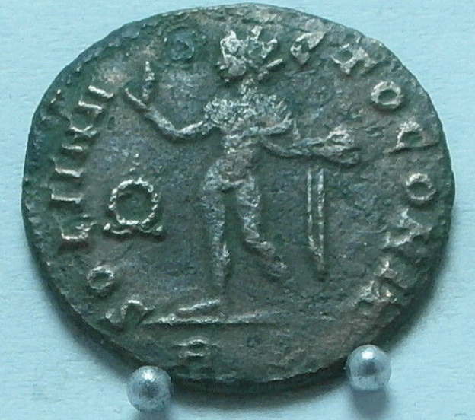

CONSTANTINE I, the Great. AE Folis, Rome mint. VF.

IMP CONSTANTINVS PF AVG. Diadem, cuirass bust right.

SOLI INVICTO COMITI. Sol standing left, holding globe. Wreath across fields.  
RP-mintmark.  
REF# RICVII 97.

**2.81g.**